**Clock Spiral (Spiral Matrix)**

**Working:**

[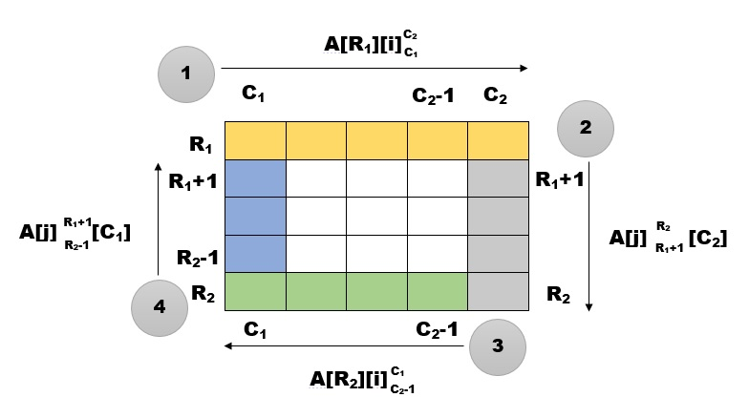](http://www.guideforschool.com/wp-content/uploads/2014/02/circular-matrix-1.jpg)

We will take a variable ‘k’ which will begin with 1 and will do the work of filling. i.e. for every cell, it will increase by 1. The below given processes will repeat till the value of ‘k’ becomes ‘n*n’

* C1 denotes the index of the column from where we have to begin. Hence its initial value will be 0.
* C2 denotes the index of the column where we have to end. Hence its initial value will be ‘n-1’ (n is the size of the matrix).
* R1 denotes the index of the row from where we have to begin. Hence its initial value will be 0.
* R2 denotes the index of the row where we have to end. Hence its initial value will be ‘n-1’ (n is the size of the matrix).

The filling up of the matrix in circular fashion will consist of 4 different steps which will continue till the matrix is filled completely.

**Step 1:** We will fill the elements of Row 0 (**R1**), starting from Column 0 (**C1**) till ‘n-1’ (**C2**). The cells which will be filled are marked in the image above in yellow color.  
The elements will be accessed as follows: **A[R1][i]**, where ‘i’ will go from **C1** to **C2** (A[ ][ ] is the array)

**Step 2:** Now, we will fill the elements of Column ‘n-1’ (**C2**), starting from Row **R1+1** till **R2**. The cells which will be filled are marked in the image above in grey color.  
The elements will be accessed as follows: **A[j][C2]**, where ‘j’ will go from**R1+1** to **R2** (A[ ][ ] is the array)

**Step 3:** Next we will fill the elements of Row ‘n-1’ (**R2**), starting from Column **C2-1** till **C1**. The cells which will be filled are marked in the image above in green color.  
The elements will be accessed as follows: **A[R2][i]**, where ‘i’ will go from **C2-1** to **C1** (A[ ][ ] is the array)

**Step 4:**Now, we will fill the elements of Column **C1**, starting from Row **R2-1** till **R1+1**. The cells which will be filled are marked in the image above in blue color.  
The elements will be accessed as follows: **A[j][C1]**, where ‘j’ will go from **R2-1** to **R1+1** (A[ ][ ] is the array)

The above 4 steps will now repeat with the inner matrix which is marked in white color in the above image. For the inner matrix,  
C1 will increase by 1 i.e. it will be C1+1.  
C2 will decrease by 1 i.e. it will be C2-1.  
R1 will increase by 1 i.e. it will be R1+1.  
R2 will decrease by 1 i.e. it will be R2-1.

The above processes will repeat till we have filled in ‘n*n’ values.

**Output:**

[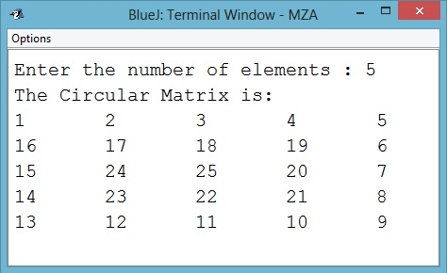](http://www.guideforschool.com/wp-content/uploads/2014/02/spiral-circular-output.jpg)